

South Ribble Local Plan
Monitoring Report
Covering the period April 2019 – March 2020

Contents

1. Introduction 2

2. Summary 2

3. Progress on revised South Ribble Local Development Scheme (LDS) 4
Central Lancashire Core Strategy/South Ribble Local Plan Review 5
Statement of Community Involvement 5
Supplementary Planning Documents 5
Overall Conclusion on Progress 6

4. Key contextual indicators for the Local Plan 2015 Performance Monitoring Framework 6
Spatial Portrait 6
Population 6
Population profile 7
Unemployment 8
Deprivation 9
Designated protected sites 10
Trees and hedgerows 10
Green space 10
Listed Buildings 11
Conservation Areas 11
Transport and spatial connectivity……………………………………………………10

5. Performance Monitoring Framework of the South Ribble Local Plan 2015 12

6. Monitoring Framework 22

Introduction

1.1 The Town and Country Planning (Local Planning) (England) Regulations 2012 updated the requirement to prepare Local Development Frameworks (LDFs), which were first introduced in the Planning and Compulsory Purchase Act 2004. In order to assess the effectiveness of the Local Development Framework policies, the regulations also require authorities to produce a Monitoring Report, (MR) which is to be prepared annually. The purpose of the MR is twofold. It will assess the implementation of the local development scheme (LDS) and the extent to which the policies in the local development documents are being successfully implemented.

1.2 This is the sixteenth Monitoring Report to be published by the council and it covers the period 1 April 2019 to 31 March 2020. The Central Lancashire Core Strategy was adopted in July 2012, and a separate monitoring report will be produced to report on its monitoring framework and will be the sixth such report. The Local Plan was adopted in July 2015. This MR will report on the Indicators within the Local Plan. This MR will fulfil the following purposes:

- Report progress on the Local Development Scheme;
- Report key contextual indicators for the South Ribble Local Plan 2015;
- Report on core output indicators;
- Report on the South Ribble Local Plan Monitoring Framework 2015.

2. Summary

The Monitoring Report recognises that monitoring impact and effect is a key part of the development planning process.

  - This MR covers five important areas;

- Reports progress on the South Ribble Local Development Scheme
- Identifies contextual indicators for the South Ribble Local Development Framework
- Reports on core output indicators;
- Reports on the Monitoring Framework of the South Ribble Local Plan (2015)
- Reports on the Monitoring Framework of the Central Lancashire Core Strategy (in a joint separate document with Chorley and Preston).

  - This MR will report on milestones using the January 2020 – December 2023 LDS, as this is the most up-to-date.

2.3 This report suggests a number of contextual indicators for the Local Plan (2015) Monitoring Framework. Their purpose is to provide a broad picture of the social, economic and environmental circumstances that exist in the borough against which the output and effects of the Local Plan policies can be measured. They effectively establish a baseline position from which change can be measured and are selected to highlight key characteristics of South Ribble.
Demographic structure: Population growth
Population profile

Socio-cultural: Deprivation

Environmental: Designated protected areas
Trees and hedgerows
Green space

Housing and built Listed buildings
environment: Conservation areas

Transport and spatial Air Quality Management Areas
connectivity: Location
Demography

2.4 Some of the indicators cannot be updated on an annual basis as they are supplied by the Census with the next being due in 2021. From those that can, the following can be reported:

      - Unemployment levels are consistently below both the Lancashire and national average, and are decreasing;
- The population of the borough continues to rise;

2.5 In relation to the Core output indicators, some key findings for the monitoring period 1 April 2019 – 31 March 2020 are:

- The number of housing completions was 412 dwellings in 2019/2020.
- There were 81 affordable dwellings completed in 2019/20, this is significantly above the target of 30 as set out in the Central Lancashire Core Strategy.
- Our three parks with Green Flag status have retained the award.

2.6 The Central Lancashire Core Strategy indicators are reported on in a separate document.

3. Progress on revised South Ribble Local Development Scheme (LDS)

  - One purpose of the MR is to report on progress in the Local Development Scheme (LDS) in relation to the milestones within it and indicate whether any adjustment to the scheme is considered necessary.

  - The Council is working jointly with Preston and Chorley Councils, and therefore there is a joint Local Development Scheme in place. The LDS is dated January 2020 – December 2023 and is therefore the most up-to-date LDS for the monitoring period this report covers.

  - The LDS included the preparation of the following Local Development Documents:

- Central Lancashire Local Plan

3.3 For more detail please see the full version of the latest revised LDS which is available to view on the council’s web site here.

3.4 The milestones for the preparation of these Development Plan Documents are shown in the table below.

3.5 Progress in relation to each of the Local Development Plan Documents is as follows:

Key Stage | Description | Timescale
Stage One  Issues and Options  (Regulation 18- statutory Consultation) | Consultation process involving engagement of all stakeholders, statutory (UU, EA, HE etc.) and non-statutory including public bodies, members of the public, developers etc.  This will include publication of the initial tranche of sites suggested for development. | Winter 2019  Consultation Period  November 2019 – February 2020
Stage two  Preferred Options  (Regulation 18) | Following Issues and Options Consultation, further detailed consideration of the sites will be undertaken looking at consultation responses and review of existing policies and drafting of the new Local Plan policies will be undertaken.  This will conclude with a ‘Preferred Options’ draft Local Plan being published for consultation. | Expected Spring/ summer2021  Consultation Period  June 2021- August 2021
Stage Three  Publication Draft  (Regulation 19) | The new draft Local Plan, the Integrated Appraisal and statement of consultation along with any topic papers | Expected Autumn 2022.  Consultation Period  October 2022 – Dec 2022
Stage Four  Submission Stage | Collation of Representations to the Publication Draft Local Plan and submission to the Planning Inspectorate ahead of the examination in public. | Submission to the Planning Inspectorate expected March 2023
Adoption | This will follow the examination in public which is expected to last between 6 and 12 months. The length of time depends on the representations made and the extent to which the Inspector requires further work to be undertaken and/or modifications to the draft plan. | November/December 2023

Central Lancashire Core Strategy/South Ribble Local Plan Review

3.6 Evidence gathering to inform the review of the Core Strategy and Local Plan is underway. Call for Sites exercises were carried out twice prior to the Issues and Options Consultation.

3.7 One milestone fell within the period this monitoring report covers. The Issues and Options Consultation was undertaken from 18 November 2019 – 14 February 2020, along with a Call for Sites 3.

3.8 The needs of Gypsies, Travellers and Travelling Showpeople will be incorporated into the reviews of the Central Lancashire Core Strategy and South Ribble Local Plan.

Statement of Community Involvement

3.8 Work on the production of a new Statement of Community Involvement has been delayed due to resources in the Planning Policy Team. It is expected that work will commence in 2021.

Supplementary Planning Documents

3.9 There are 9 Supplementary Planning Documents which are currently adopted, 7 of these are Central Lancashire SPDs with 2 being South Ribble documents.

- Affordable Housing
- Design
- Controlling re-use of Employment Premises
- Rural Development
- Access to Healthy Food (currently under review)
- Open Space and Playing Pitch
- Residential Extensions (South Ribble)
- Renewable and Low Carbon Energy (South Ribble).
- Biodiversity and Nature Conservation

3.10 The LDS does not indicate that any new SPDs will be produced. The need for new SPDs or review of existing SPDs will take place as the review of the Local Plan is carried out.

Overall Conclusion on Progress

3.11 The milestones for production of the Local Plan that fell within the Monitoring Period. The next milestone is timetabled for Spring/Summer 2021, however at this stage it is unclear how circumstances such as the current Pandemic will affect this.

4. Key contextual indicators for the Local Plan 2015 Performance Monitoring Framework

Spatial Portrait

4.1 The borough of South Ribble is situated in the centre of Lancashire and is immediately to the south of the River Ribble. It has excellent communication links from its location astride the north/south M6 motorway, and the main London to Glasgow railway. Connections are available to the M55, M61 and M65 motorways as well as the A6, A49 and A59 roads. Rail links are also available to East Lancashire, the Fylde, Greater Manchester and Merseyside. The borough is less than an hour’s drive from the airports at Manchester and Liverpool. The borough has an area of 44 square miles, with approximately 7,730 hectares of greenbelt land, which is approximately 68% of the total area.

Population

4.2 The population of the borough is estimated to be 110,788 (Source: Office National Statistics (ONS): Mid-Year Population Estimates 2019). The total population for the majority of the time has been rising over the last 30 years as shown in the following chart.

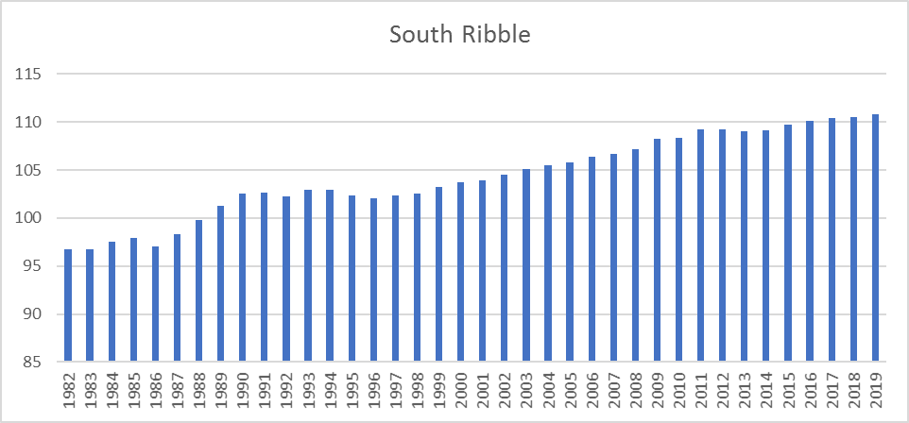
(Source: ONS - mid-year estimates)

4.3 It is projected to continue growing as shown below, although the projections are trend based and do not take into account the effects of strategic policy.

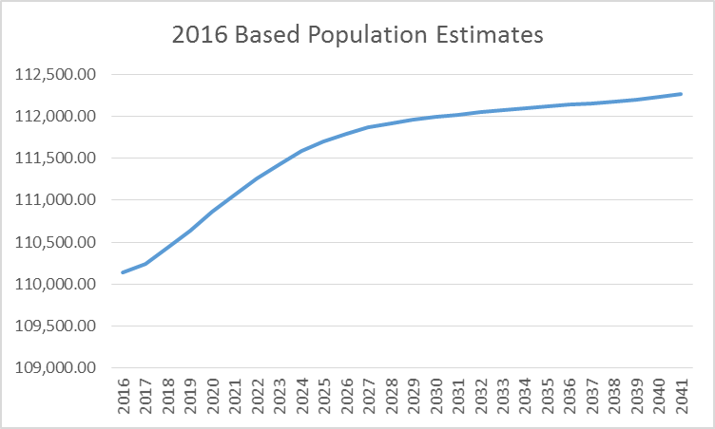
(Source: ONS: Subnational Population Projections)

4.4 Comparison with the mid-year estimates and the next census (2021) will show what the actual growth has been against the projected growth. A key issue for the Local Plan is to what extent spatial planning policies will impact population growth.

Population profile

4.5 At the time of the 2011 Census, the usual resident population of the borough was approximately 109,057 broken down into the following age groups.

South Ribble Compared with England & Wales

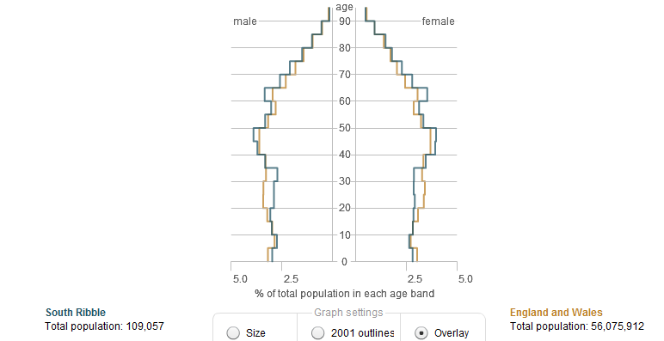
(Source: 2011 Census ONS - Crown copyright)

South Ribble – 2001 Compared with 2011 (outline shows 2001)
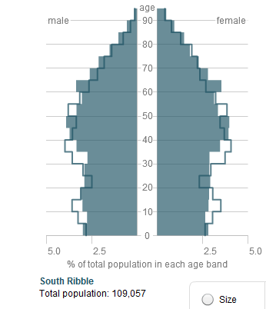
(Source: 2011 Census ONS - Crown copyright)

4.6 The most noticeable variations in the borough’s population from the national average are: fewer adults in the 20-34 age groups and more people in the 60-64 age group. The borough has had a younger than average population over the last 20 years, largely related to in-migration of young people in the new town era. Twenty years on this could account for higher proportions of pre-retired people i.e. those who came here in the 1970s and 1980s.

Unemployment

4.7 The following figures show the current unemployment rates (based on Nomis-official labour market statistics. Note: numbers and % are for those aged 16 and over. % is based on a proportion of those economically active.

4.8 The unemployed rate is based on the model used above at July 2019 was 2.5% in South Ribble, which is the same as the Lancashire rate of 2.5% and also below the North West rate of 3.9%.

Deprivation

4.9 The Indices of Multiple Deprivation (IMD) measure seven different aspects (or domains) of deprivation for lower level super output areas across England: Income, Employment, Health and Disability, Education, Skills and Training, Barriers to Housing Services, Living Environment and Crime. These are weighted and combined to create the overall IMD. Deprivation is reported down to Lower Super Output Areas (LSOAs); these are subdivisions of wards and contain a minimum of 1,000 people and 400 households. The Indices of Deprivation identifies concentrations of deprivation and it is important to note that not all deprived people live in deprived areas and, conversely, not everyone living in a deprived area is deprived. It is not a measure of affluence.

4.10 The indicators have been chosen because they represent different aspects of deprivation. A lack of deprivation does not necessarily equate to affluence. Therefore, the LSOAs with the highest ranks are not necessarily affluent, just less deprived. The English Indices of Deprivation 2019 rank South Ribble 210 out of 317 local authority areas in England. This indicates that the borough does not suffer from high levels of deprivation. Nonetheless, at a more detailed level, the indices show that there are small areas within the borough with problems related to deprivation. Two LSOA’s fall within the worst 10% most deprived areas of England. By comparison, South Ribble has twelve LSOAs in the best 10%.

4.11 The council, in conjunction with its partners across many agencies continues to work to address the deprivation issues. The map below shows deprivation levels across the Borough according to the Indices of deprivation 2019.

Deprivation Levels by Lower Super Output Area
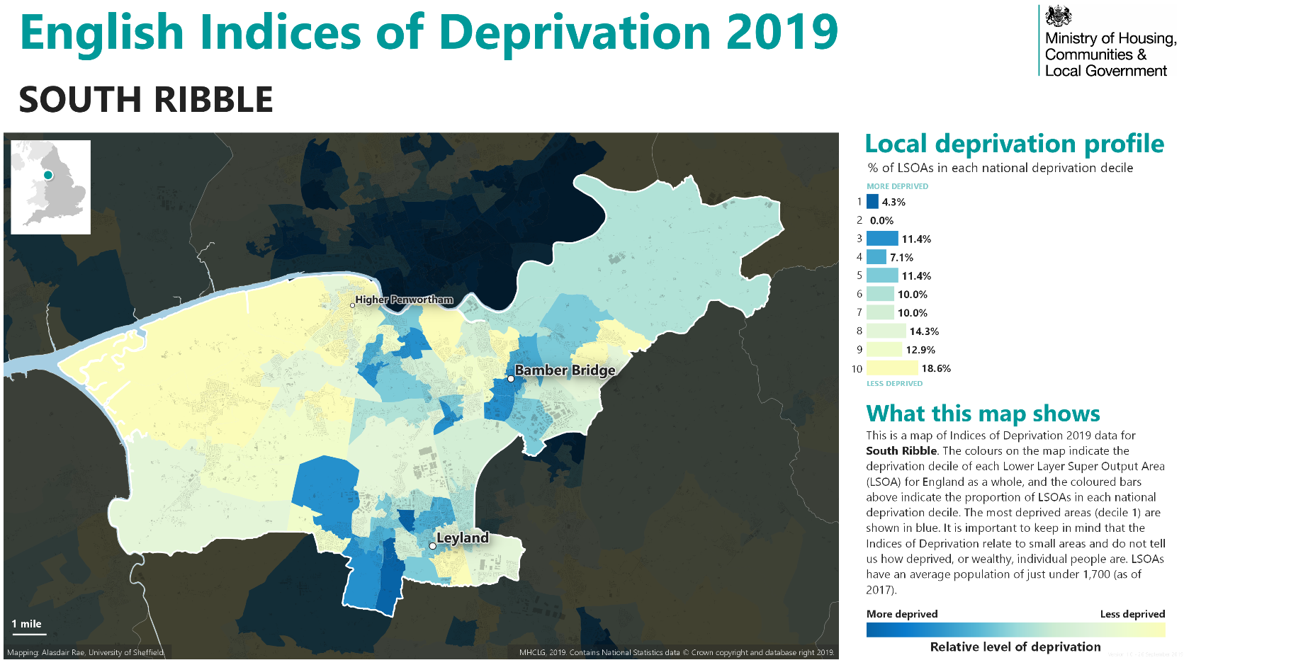
Source: Lancashire County Council

Designated protected sites

4.12 478.5 hectares or 4.1% of the borough is protected as Sites of Special Scientific Interest (SSSIs) or Local Nature Reserve etc. An objective of the Local Development Framework is to ensure that development does not harm protected sites and habitats. Work is completed on a Habitats Regulations Assessment to ensure protection of these important sites. This was published alongside the Central Lancashire Core Strategy and the South Ribble Site Allocations Partial Version document in November 2013.

Trees and hedgerows

4.13 Twenty-seven areas or a total area of 231.6 hectares is protected as ancient woodland. 390 tree preservation orders (TPOs) were in force in the borough as of 2020, protecting individual or groups of trees and woodlands. This figure does fluctuate as trees can be felled by storms, become unsafe or new designations can be put in place.

Green space

4.14 An Open Space and Recreation study was completed in July 2012 and includes an up-to-date audit of open space provision in the borough and provides a baseline for monitoring changes to the overall amount to inform the LDF process. The study identifies almost 730 hectares of open space in the borough. (Source: Open Space Study database 2012). This includes land in public and private ownership and land which has active or passive use. There is currently a new Open Space Study underway, which is due to be completed in 2018.

Listed Buildings

4.15 The borough has 144 entries on the listed buildings register as being of special architectural or historic importance. Two are grade I buildings of national interest, ten are grade II* buildings and the remainder grade II.

Conservation Areas

4.16 There are eight conservation areas in the borough, and each has an appraisal and management plan. It is intended that these appraisals and management plans will be regularly reviewed and kept up to date. The Conservation Area Appraisals for each of the 8 Conservation Areas were published early in 2014. New Conservation Areas will be designated in the future where appropriate, in areas that merit such a designation.

Transport and spatial connectivity

4.17 The borough of South Ribble is situated in the centre of Lancashire, and is immediately to the south of the river Ribble. It has excellent communication networks from its location astride the north/south bound M6 motorway and the main London to Glasgow railway line. Connections are also available to the M55, M61 and M65 motorways as well as the A6, A49 and A59 roads. Rail links are also available to East Lancashire, the Fylde, Greater Manchester and Merseyside. The borough is less than an hour’s drive from Liverpool and Manchester.

Self-build and Custom Housebuilding Register

4.18 The Self-build and Custom Housebuilding Act 2015 placed a duty on all local authorities to keep a register so that an assessment of demand in the local area for this type of housebuilding can be made. This is the third reporting year for self-build and custom housebuilding. The headline data from the register shows that we have 35 applicants (all of which are individuals) on the register (low demand) as at 31 March 2019, this has gone up by 13 in the previous 12 months when compared to the 2018 figure. Please see table below for further details:

4.19 In line with the above the council established a register that has been open for entries from April 2016. In addition, there is a page on the Council’s website relating to self and custom build, and there is a form on it that people can submit electronically or download and fill in to request inclusion on the register. The council requires individuals or associations of individuals to provide: contact details; their preferred location(s), type and size of property (number of bedrooms) they wish to build and the budget etc. To go to the website page please click here.

Group/Individual | Area of Interest | Number of Dwellings/Bedrooms | Type of Dwelling | Size of Plot
Individual | South Ribble | 1 | Detached House | Unknown
Individual | Penwortham, Hoole,Hutton, Walmer Bridge, Longton and surrounding areas. | 1 | Detached House | Unknown
Individual | South Ribble | 1 | Detached House | Unknown
Individual | South Ribble | 1 | Detached House | 0.5ha
Individual | Leyland | 1 | Detached House | 0.5ha
Individual | South Ribble | 1 | Detached House | Upto 0.25ha
Individual | South Ribble | 1 | Detached House | 0.25ha
Individual | South Ribble | 1 | Detached Bungalow | 0.25ha
Individual | Penwortham | 1 | Detached House | 1ha
Individual | South Ribble | 1 | Detached House | 0.125ha
Individual | South Ribble | 1 | Detached House | 0.013 - 0.020
Individual | Longton | 1 | Detached House | Unknown
Individual | South Ribble | 1 | Detached House | Unsure
Individual | South Ribble | 1 | Detached House | 0.5ha
Individual | South Ribble | 1 | Detached House | 4ha
Individual | South Ribble | 1 | Detached House | 0.05ha
Individual | South Ribble | 1 | Detached House | 0.3ha
Individual | Walton-le-Dale | 1 | Detached House | 0.15ha
Individual | New Longton | 1 | Detached House | 1 acre
Individual | South Ribble | 1 | Detached House | 0.25ha
Individual | South Ribble | 1 | Detached House | 0.25ha
Individual | Penwortham | 1 | Detached House | 0.5acres
Individual | South Ribble | 1 | Detached Bungalow | 0.2ha
Individual | Hutton | 1 | Detached House | 0.3ha
Individual | Penwortham | 1 | Detached House | 0.1ha
Individual | South Ribble | 1 | Detached House | 0.5-2.0ha
Individual | Penwortham | 1 | Detached House | Various
Individual | South Ribble | 1 | Detached House | 0.3-0.4ha
Individual | South Ribble | 1 | Bungalow | 0.04ha
Individual | South Ribble | 1 | House | 2-4ha
Individual | South Ribble | 1 | House | Enough for a 3-4 bed detached house
Individual | Penwortham | 1 | House | 0.25
Individual | South Ribble | 1 | House | 0.06ha
Individual | Longton | 1 | House | 0.1ha
Individual | South Ribble | 1 | House | 0.1ha

5. Performance Monitoring Framework of the South Ribble Local Plan 2015

5.1 The Local Plan (2015) Indicators within the Performance Monitoring Framework are monitored. These indicators are below and are considered necessary to accurately measure the effectiveness of the policies within the Local Plan.

Level of Nitrogen Dioxide at the Air Quality Management Areas (AQMA)

Policy/Policies this contributes to - A1, A2, A3

5.2 There are currently five declared AQMA’s within the South Ribble area. All of the declared AQMA’s have been declared for the likely exceedance of the Nitrogen Dioxide annual mean objective of 40µg/m³. During this monitoring period Victoria Road in Walton-le-Dale (AQMA 2) is the only area that has exceeded the objective of 40µg/m^{3,} the other areas are slightly under the objective.

5.3 The five current AQMA areas are;

AQMA 1 - Cop Lane, Priory Lane, Penwortham
AQMA 2 - Victoria Road, Walton-le-Dale going into Preston
AQMA 3 - Tardy Gate/Brownedge Road, Lostock Hall
AQMA 4 - Station Road, Bamber Bridge
AQMA 5 - Turpin Green Lane/Golden Hill Lane, Leyland.

5.4 The Council’s current Borough wide Air Quality Action Plan includes measures and actions that are being undertaken to improve and maintain air quality. These include measures which will be taken via the development management process to reduce the impact from developments and to encourage the use of alternative forms of travel. The Air Quality Action Plan (AQAP) and more information regarding air quality in South Ribble is available here.

5.5 The Council have published a Planning Advisory Note: Low Emissions and Air Quality, A Guide for Developers detailing the preferred methodology that should be followed when undertaking an assessment of the impacts of development on air quality.

Changes to Road Traffic Congestion (Core Strategy Policy 3)

Policy/Policies this contributes to - A1, A2, A3

5.5 The Department for Transport (DfT) carries out traffic monitoring in the Central Lancashire area. The monitoring sites are in locations known to experience significant volumes of traffic. These will be monitored each year so will show any trends up or down.

5.6 The table below shows the 7-day average figures for each of the 6 locations across the area of South Ribble.

South Ribble Data
Traffic Counts

Year | Location
Year | 1 | 2 | 3 | 4 | 5 | 6
2012 | 24495 | 26962 | 18337 | 39533 | 25083 | 34009
2013 | 24403 | 26841 | 18309 | 38889 | 25136 | 33899
2014 | 24671 | 26960 | 18831 | 39830 | 23103 | 31591
2015 | 24468 | 26661 | 17664 | 38558 | 24087 | 32836
2016 | 24238 | 26330 | 18217 | 39445 | 24872 | 33882
2017 | 24667 | 29287 | 18139 | 40504 | 24859 | 33762
2018 | 24727 | 29304 | 18177 | 40662 | 25361 | 32894
2019 | 24776 | 29981 | 16418 | 46407 | 25404 | 32960

Location of Monitoring Sites in South Ribble

1 A582 Penwortham Way, S of Lodge Lane, Farington Moss (CP 28720)
2 A6 London Way, N of B6230 (CP 18511)
3 A59 Liverpool Road, S of Hutton Roundabout (CP 56605)
4 A6 South Ribble Way, S of A582, Farington (CP 99554)
5 A6 Lostock Lane, W of M6 J29a, Bamber Bridge (CP 28555)
6 A59 Preston New Road, W of Cuerdale Lane, Samlesbury (CP 16566)

5.7 Locations 1, 2, 4 and 5 above have shown a slight increase during the periods recorded. However, locations 3 and 6 have shown a slight decrease as shown in the table above. The overall increase on the 2017 figure is 4821. It is expected that traffic levels will rise further overall as more new development occurs across South Ribble.

5.8 It is important that appropriate infrastructure is put in place to cope with the extra traffic associated with this development. It is also necessary to ensure that appropriate sustainable transport infrastructure is put in place as part of development, to try and reduce the number of cars on the road. We will continue to monitor traffic levels in South Ribble.

5.9 The Central Lancashire Highways and Transport Masterplan (March 2013) represents Lancashire County Council’s priorities for future investment in highways and transport across Central Lancashire and a delivery programme to 2026 which will see new road space built, public transport prioritised across key corridors into Preston and between Leyland and Chorley, and public realm improvements in city, town and local centres.

5.10 The description of Monitoring Sites above includes a 'Count Point' (CP) id for each location (e.g. CP28720). Traffic data from the year 2000 for these and all Count Points in Central Lancashire and nationwide can be viewed on the Department for Transport's website at; www.dft.gov.uk/traffic-counts.

Gross Affordable Dwellings Constructed (Core Strategy Policy 7)

Policy/Policies this contributes to - A1, B2, C1, C2, C3, D1, D2

5.11 There has been 81 affordable dwellings completed in the 2018/19 monitoring year, this exceeds the target of 30 as set in the Central Lancashire Core Strategy and is 20% of the overall completion figure of 412 set out below at 5.25 which is a similar percentage to 2018/2019. We expect the number of affordable homes to increase in the future with more large permissioned sites contributing to their development. For more details please refer to the latest Housing Land Position Statement.

Value of Developer Contributions Collected (and spent on infrastructure priorities) (Core Strategy – Policy 2)

Policy/Policies this contributes to - A1, C1, C2, C3, C4, C5, D1, D2, G9, G10, G11, H1

S106 contributions collected | S106 contributions spent | CIL collected | CIL spent on 123 List | CIL transferred to Parish Councils
£1,332,783 | £1,080,077 | £3,082,728 | £1,297,570 | £0

5.12 The table above shows that during this monitoring period £1,332,783 of S106 monies were collected and the capital expenditure funded from S106 monies was £1,080,077. The amount of CIL contributions collected during the monitoring year was £3,082,728 with £1,297,570 going to be paid to Lancashire County Council for spending on infrastructure priorities. None has been paid over to the relevant Parish Councils in accordance with CIL regulations.

Net amount of sport, recreation and informal open spaces lost to other uses (Core Strategy Policy 18)

Policy/Policies this contributes to - A1, G1, G3, G4, G5, G6, G7, G8, G9, G10, G12, G13, H1

5.13 During this monitoring period there has been nil loss of sport, recreation and informal open spaces to other uses.

5.14 To enable the Enterprise Zone to be delivered at BAE Systems Samlesbury the green belt boundary was amended in accordance with policy C5–BAE Systems, Samlesbury of the South Ribble Local Plan.

Quality rating of public open spaces

Policy/Policies this contributes to - A1, G7, G8, G9, G11, G12

5.15 75% of the public open spaces that have been assessed within the borough are rated as high quality (as at March 2018). This indicator has not been monitored over the monitoring period covered by this report, so the figure of 75% may not be up to date as the most recent assessment work did not assess the sites in this way.

No reduction in range of uses within the boundary of the Capitol Centre

Policy/Policies this contributes to - B5

5.16 There has been no reduction in the range of uses within the boundary of the Capitol Centre during this monitoring period.

Higher quality building design (Core Strategy Policy 17)

Policy/Policies this contributes to - C1, C2, C3, G17

5.17 All housing developments in South Ribble have been considered against the criteria set out in Policy 17 of the Core Strategy and the Adopted Central Lancashire Design SPD, which uses the principles set out in the original Building for Life (BfL) standard. As well as this, developments are also considered against policy G17 of the South Ribble Local Plan (adopted July 2015) and together ensure that a high quality of design can be achieved.

% of JSA claimants (age 16 to 64) below the Lancashire average

Policy/Policies this contributes to - B3, B4, C4, C5, E1, E2

5.18 Official statistics show that 4.3% of the working age population in South Ribble were claiming JSA. Which is below the Lancashire figure of 5.9%.
(Source: ONS. Note: % is the number of claimants as a proportion of resident population of area aged 16-64 claiming Job Seekers at November 2020).

Net loss of employment to another use (ha)

Policy/Policies this contributes to - B3, B4, C4, C5, E1, E2

5.19 0.00ha of employment land use has been lost during the monitoring period.

Planning to adapt to climate change (Core Strategy Policy 27)

Policy/Policies this contributes to - B3, B4, C1, C2, C3, C4, C5, E1, E2, G17

5.20 In March 2015 the Deregulation Act received Royal Assent which proposed that all energy efficiency standards will be included in building regulations. As a result, the Code for Sustainable Homes has been withdrawn. The Code for the Sustainable Homes requirement in Policy 27 of the Core Strategy is therefore no longer required.

5.21 The government has set out transitional arrangements until energy efficiency standards are included in building regulations which allow local authorities to continue to apply policies in their local plans that require compliance with energy efficiency standards that exceed building regulations.

5.22 In accordance with the transitional arrangements South Ribble is requiring all new dwellings to achieve a minimum Dwelling Emission Rate (DER) of 19% above 2013 Building Regulations which is equivalent to Code Level 4 energy requirements. Compliance with other aspects of the Code for Sustainable Homes is no longer required.

Increase in public transport/bicycle/walking as method of travel to work

Policy/Policies this contributes to - B1, D1

5.23 The table below shows that over half of the working age population travel to work as either a driver or a passenger in a car or van. This is higher than both the regional and the national average. Less people than the regional and national average travel to work on foot, or via train or bus, however, the percentage of people that travel to work on a bicycle is slightly higher than both the regional and national average. This indicator will next be reported on when the next census information is made available sometime during 2021.

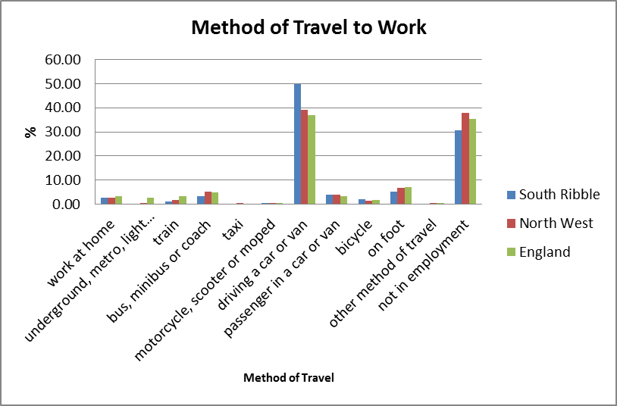

Completed development complying with car parking standards (residential and non-residential)

Policy/Policies this contributes to - B1, F1

5.24 All completed development complied with parking standards were required.

Meet South Ribble annual housing requirement

Policy/Policies this contributes to - D1, D2

5.25 During the 2018/19 monitoring year there were 412 dwelling completions in the borough.

Net additional housing expected to come forward each year over the remaining plan period to meet the overall housing requirement. (This should take into account the previous delivery of dwellings since the start of the plan period).

Policy/Policies this contributes to – D2

5.30 At April 2020, The Borough had in excess of a five year supply of dwellings.

 | Requirement
Annual Requirement | 190.59
Annual Requirement plus 5% buffer | 200.12
Current five-year supply (see Appendix 3) | 2685.00
Supply excluding 10% of small sites | 2664.60
Annual Need figure (incl 5% buffer) | 200.12
Supply (Years) | 13.32

5.31 The following housing trajectory chart relates to the current strategic requirement at 31 March 2020.

Type of Site | Developable Units 2025/26 | Developable post 1/4/26
Large sites with permission >1 ha | 233 | 1513
Medium sites 0.5 ha ≤ Site Size ≤ 1 ha with permission | 0 | 0
Small sites with permission ˂0.5 (incl PD and permission not required) | 0 | 0
Additional allocated Local Plan sites | 206 | 1617
Unidentified Windfalls | 150 | 150 per annum
TOTAL | 589 | 3130 + windfalls

Type of Site | 2020-21 | 2021-22 | 2022-23 | 2023-24 | 2024-25 | 2025-26 | Deliverable post 1/4/26
Large sites with permission >1 ha | 301 | 325 | 352 | 363 | 313 | 233 | 1513
Medium sites 0.5 ha ≤ Site Size ≤ 1 ha with permission | 6 | 7 | 0 | 0 | 0 | 0 | 0
Small sites with permission ˂0.5 (incl PD and permission not required) | 101 | 67 | 26 | 10 | 0 | 0 | 0
Additional allocated Local Plan sites | 0 | 0 | 26 | 50 | 138 | 206 | 1617
Unidentified Windfalls estimate | 50 | 100 | 150 | 150 | 150 | 150 | 150 per annum
TOTALS | 458 | 499 | 554 | 573 | 601 | 589 | 3130 + windfalls

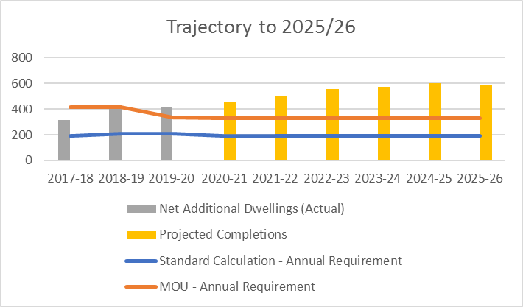

Source: SR Housing Land Position Statement 2019
For more details please refer to the latest Housing Land Position Statement.

Proportion of agricultural workers dwellings approved

Policy/Policies this contributes to - D3

5.32 No agricultural dwellings have been approved within this monitoring period.

Proportion of A1, A3 and A4 uses in Leyland Town Centre

Policy/Policies this contributes to - E3

 | A1 | A3 | A4
Leyland Town Centre | 40% | 4% | 4%
Within Primary Retail Frontage | 49% | 6% | 7%

5.33 The Local Plan 2015 sets a target of a minimum of 60% A1 units in the primary retail frontage. This indicator reports on the amount of A1, A3 and A4 uses, which currently is below the 60% target set in the Indicator, and the target of 60% or more A1 uses set in the policy, in both the town centre and primary retail frontage.

5.34 The proportion of A1 units is currently below the target set in the policy, applications for non-A1 uses should therefore not currently be supported unless there are exceptional circumstances.
Please see the latest Retail Position Statement for more detail.

Proportion of A1, A3 and A4 uses in district centres

Policy/Policies this contributes to - E4

District Centre | A1 | A3 | A4
Penwortham | 42% | 11% | 3%
Bamber Bridge | 43% | 4% | 4%
Tardy Gate | 57% | 6% | 2%
Longton | 41% | 8% | 0%

5.35 Policy E4 of the Local Plan 2015 sets a target of a minimum of 60% A1 uses in the district centres. The Indicator in the Monitoring Framework has a target of the proportion of A1/A3 and A4 uses combined being more than 60%. For centres where the 60% target for A1 uses has not been met, no further applications for non-A1 uses should not be permitted unless there are exceptional circumstances.

5.36 None of the district centres currently meet this target within the Monitoring Framework, with some centres being significantly below the target.

Proportion of A1, A3 and A4 uses in local centres

Policy/Policies this contributes to - E5

Local Centre | A1 | A3 | A4
Kingsfold | 31% | 2% | 2%
Earnshaw Bridge | 50% | 0% | 0%
Farington | 36% | 0% | 5%
Higher Walton | 35% | 0% | 10%
Seven Stars | 61% | 3% | 6%
Walton Le Dale | 22% | 0% | 9%
Gregson Lane | 46% | 8% | 0%
New Longton | 82% | 9% | 0%
Walmer Bridge | 39% | 6% | 6%
5.37 Policy E5 of the Local Plan 2015 sets a target of a minimum of 60% A1 uses in the local centres. The Indicator in the Monitoring Framework has a target of the proportion of A1, A3 and A4 uses combined being more than 60%.

5.38 For centres where the 60% target for A1 uses has not been met, no further applications for non-A1 uses should be permitted unless there are exceptional circumstances.

5.39 Only two of the local centres currently meet the target within the Monitoring Framework, with some centres being significantly below the target.

Vacant units in town/district/local centres

Policy/Policies this contributes to – B4, B5, E3, E4, E5

Retail Centres | % Vacant
Leyland Town Centre | 6%
Penwortham District Centre | 4%
Bamber Bridge District Centre | 1%
Tardy Gate District Centre | 9%
Longton District | 5%
Kingsfold Local Centre | 7%
Earnshaw Bridge Local Centre | 5%
Farington Local Centre | 9%
Gregson Lane Local Centre | 8%
Higher Walton Local Centre | 0%
New Longton Local Centre | 0%
Seven Stars Local Centre | 3%
Walmer Bridge Local Centre | 0%
Walton-le-Dale Local Centre | 4%

5.40 The table above shows that three of the centres in the Borough have a 0% vacancy rate, these are New Longton, Walmer Bridge and Earnshaw Bridge. Farington and Tardy Gate have the highest rate.

5.41 The target of no increase in vacant units for three consecutive years within the town and district centres in the performance indicator of the Local Plan 2015 has been met. Vacancy rates will continue to be monitored in order to ensure the effectiveness of the policies.

Percentage of Buildings in Greenbelt approved for re-use

Policy/Policies this contributes to - G2

5.43 100% of applications that met policy requirements were approved for re-use in the green belt.

Loss of trees/woodland protected by TPOs

Policy/Policies this contributes to – G13

5.44 390 tree preservation orders (TPOs) were in force in the borough as of March 2020 protecting individual or groups of trees and woodlands, this figure is higher than last year so there was no loss. However, trees protected by a TPO can be removed for various reasons i.e. damaged, being structurally unsound and leaning etc.

Number of Green Flag awards for parks/green spaces in the Borough

Policy/Policies this contributes to - G7

5.45 Three of the borough’s parks/green spaces have been awarded the Green Flag award for 2017/18. This is the same as previous years so there has been no loss of the Green Flag awards.

Worden Park to maintain Green Flag status

Policy/Policies this contributes to - G9

5.46 Worden Park has maintained its Green Flag status for the 2017/18 monitoring period.

Development on unstable or contaminated land contrary to policy

Policy/Policies this contributes to - G14

5.47 There was no development on contaminated land contrary to policy in this monitoring period. Any proposals for development of this type of land would have to be in accordance with policy G14 of the Local Plan.

Development on derelict land contrary to policy

Policy/Policies this contributes to - G15

5.48 No development took place on derelict land contrary to policy in this monitoring period. Close working between the Planning Policy and Development Management teams will ensure that any future schemes on such sites are in accordance with policy G15 of the local plan.

6. Monitoring Framework

6.1 The council recognises that monitoring and review are important in producing an effective Local Plan. Monitoring helps measure the outputs and outcomes of policies, but it also helps to establish a sound evidence base upon which polices can be developed.

6.2 The monitoring process is ongoing and integral to the Local Development Document process.

6.3 The Planning Policy team already has good monitoring systems in place and gathers information such as;

- Housing and employment land completions;
- Town/district/local centre health checks;
- Data on housing need with housing colleagues;
- Working across boundaries with other districts to understand the characteristics of the wider central Lancashire area e.g. the Core Central Lancashire sub regional strategy commissioned jointly with Preston CC and Chorley BC;
- Evidence from commissioned studies e.g. the South Ribble Retail Study (2017), the Central Lancashire Open Space Assessment (2019); Central Lancashire Employment Land Study (2017) with accompanying 2019 update, and the Central Lancashire Strategic Housing Market Area Assessment (SHMAA) 2017.
- Maximise the use of published data e.g. from the ONS website and the Lancashire Profile website;
- Developing the Corporate Land and Property system (including GIS) to store and analyse spatial data;
- Working with Lancashire County Council to develop our monitoring information.
- Develop the evidence bases for the LDF, jointly with Preston and Chorley Councils, e.g. the Joint Employment Land Review and the Strategic Flood Risk Assessment.

At year end, permissions for dwellings on small sites (less than 0.5 ha) totalled 204. Based on experience, it is estimated that 10% of these dwellings will not be built.

